Biomedical Optics Research Laboratory and Department of Science & Technology Studies, University College London.

Optical imaging project at UCL
SPRING 2009

This newsletter is being sent to you as a participant in the project to test a new method of making images of the breast using beams of light. The initial project to test-run the novel equipment designed in the Medical Physics Department at University College London, is now completed, but work continues in other ways. This newsletter gives a brief summary of what was achieved with your help and cooperation, and gives information on the direction in which the work on this new method of imaging is going and ways of keeping in touch. As we have said before, the part played by you as a volunteer in the development of this technology has been absolutely crucial.

PROGRESS OF THE RESEARCH

We reported in the last newsletter that the second series of experimental scans of the breast ended in late 2007, but work on analysing and writing up results went on, as did studies (using the same technology) of blood flow in the brains of premature babies. This brought to an end the programme of interviewing volunteers at UCL, but the collaboration with the University of California (also mentioned in the last Newsletter) continued, with a total of 15 volunteers on their site being interviewed. We have also undertaken some more interviews and discussions with researchers doing studies involving volunteers and with patients who sit on research advisory committees, in order to get other perspectives on volunteers’ role. We have also been analysing all the data you have given us (that includes both the technical stuff coming out of the scans and the insights into what matters to volunteers and patients we get from the interviews) and writing it up so that it can be published and the information shared with other people. We give more details about these activities below.

First – a little bit of history

You all came into the project at different stages, so only relatively few will be familiar with the early stages. As this is the last Newsletter, here is a brief summary of the key dates and developments of the testing programme in which you were involved. The idea of gathering feedback from volunteer test subjects as part of the test programme was first discussed in late 1999. We had to get ethical committee approval for doing interviews, get funding and so on before we were ready for the first volunteer. So the first breast scan (as opposed to scans of plastic simulations or the male researchers arms) did not take place until 2001. At that time we were using a patient interface where the patient sat up and leaned forward into a frame with a conical aperture (see the illustration overleaf).

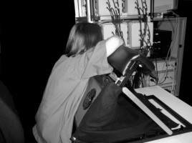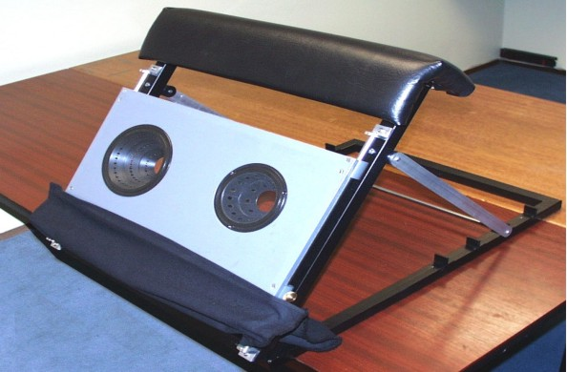

Eighteen women volunteers (3 healthy, and 15 recruited by consultants at the breast clinic) were scanned using this interface and interviewed afterwards. (There were a few more who were scanned but could not be interviewed for one reason or another.) Volunteer feedback told us that it was pretty uncomfortable holding this position for up to 10 minutes, and difficult to know if the breast was properly positioned. Technically also the results were rather poor, since light leaked in round the edges, spoiling the data. So almost from the start the physics team were working on a new interface design. Nevertheless, a lot was learnt; some images were brilliant, showing it could work, and the interviews gave new insights into what was important for volunteers and patients, not just in relation to this technology but to health technology development in general.

The second series of scans started in summer 2005. For most of this project there were 2 part-time social scientists covering the interviews, so we did not miss too many. We interviewed 47 women after their scan, and observed another 5 who were unable, or preferred not to stay for an interview. The interface had been radically re-designed so it now worked like a bed, where the volunteer lies face down. In diagrammatic form, showing ‘the works’ underneath, it looks like this:

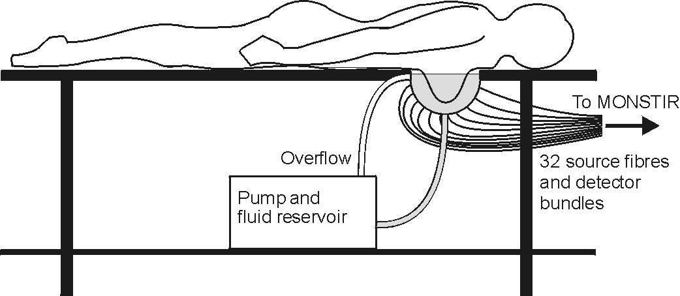

Having a padded top, white sheets and a pillow, most people found the bed comfortable, and some even described it as relaxing. And the team were consistently getting excellent images, thanks to volunteer cooperation and the milky fluid in the ‘cup’, which ensured there were no gaps between the breast and the optical fibres and detectors all round the cup. We made quite a lot of technical and procedural improvements during the period of testing. For example, scan-time was reduced to 5 minutes, and earlier volunteers’ questions and comments were used in briefing those who came later, reducing the stresses of taking part, and improving the apparatus. Very importantly, the images obtained from the scans on volunteers showed that the instrumentation could produce reliable information on the healthiness of the breast tissues.

Where we have got to

Louise Enfield, who ran all the test scans for the second series and generated the images from the measurements recorded during each scan, explains what has been achieved:

“We had very encouraging results, showing our ability to distinguish between scar tissue, malignant tumours and benign lesions. Different types of lump have a distinct pattern of the blood and oxygen levels in the lesion compared to healthy breast tissue. We are extremely grateful to everyone who gave up their time and energy to help us out-we couldn’t do our work without you.”

THE NEXT PHASE OF DEVELOPMENT

Louise continues:
“We have just received another two and half years funding from Cancer Research UK, the Medical Research Council and the Engineering and Physical Sciences Research Council. These funding bodies have grouped together to fund four Cancer Imaging Centres, resulting in a large increase in funding for research into cancer imaging in the UK. UCL, in partnership with Kings College London, is one of the four centers and our group has been awarded some of this money.

We are going to follow women through a course of neoadjuvant chemotherapy, performing optical scans prior to treatment, two weeks after the start, half way through the course of chemotherapy and at the end of their treatment prior to surgery. We hope to be able to detect changes in blood and oxygen over the course of the chemotherapy, as the drugs reduce the size and physiological makeup of the tumour. I will be carrying out the scans as before, and will analyse all the results. We shall compare our images with MRI and biopsy results and see how they compare, and at what stage in the chemotherapy treatment we can detect changes in the tumour. This next phase of the optical imaging project is being carried out in collaboration with nurses, radiologists and surgeons at Guy’s Hospital (including Mr. Douek who has moved over there).”

MORE PUBLICATIONS: ON VOLUNTEERS’ ROLE AND COLLABORATIVE WORKING

Two papers directly relating to the work concerned with volunteer feedback and the working relationships needed for successful research have been published, and two more accepted for publication.

One publication is the write-up of a poster presented at a conference on Biomedical Optics in 2008. This was presented to an audience of biomedical scientists with the aim of encouraging them to listen to and interact more with volunteers in their experiments. Hence it is titled How feedback from human subjects can enhance clinical performance of optical mammography and emphasizes the positive effects for research of, for example, building a good researcher-subject relationship and being sensitive to issues of personal privacy.

The other paper is a study of the working relationship between the researchers who collaborated on this project, coming from very different backgrounds (physical sciences and social sciences) and needing to learn about each other’s way of working. It is called: Evolving collaborations: a self-referential case-study of a social/natural sciences collaborative project. (In Science Studies, 2, 27-46).

The two papers that will shortly be published are:

Morris, N., Armstrong, V., & Balmer, B. (in press). Constructing a safe research environment: technology talk between researchers and volunteer research subjects. Health, Risk and Society, 11.

Armstrong, V., & Morris, N. (in press). Boundary setting in breast cancer research: a study of the experience of women volunteer research subjects. Sociology of Health and Illness.

The full text of all these will be posted on the website except where copyright restrictions apply. The website address is
http://www.homepages.ucl.ac.uk/~ucrhnom/index.htm

Project at university of California

This project has been completed and written up (another paper that has been accepted but waiting to be published). Fifteen women were interviewed, the majority of them healthy volunteers. We compared their responses to being a volunteer with the data from the volunteers interviewed in the London study. While there were quite a lot of differences, there were also interesting similarities. Both groups showed more concern about the social than the physical challenges of participation, and used similar strategies to manage these tensions. These similarities in two contrasting environments (though it was testing optical technology in both cases) show that feelings of awkwardness, embarrassment, and not wanting to be treated like an object (or a ‘guinea pig’) are not just confined to our setting. Equally, with some cooperation from the researcher, most women can manage them successfully (at least within the kind of low-risk, non-therapeutic research we studied). We suggest in the paper that there are lessons researchers can learn from this: they need in particular to be aware that a good researcher-researched working relationship can play a key role in achieving mutually satisfactory outcomes.

The paper is called: ‘Volunteer Research Subjects’ Experience of Participation in Research on a Novel Diagnostic Technology for Breast Cancer’, by Norma Morris and Margaret Scheider, to appear in Qualitative Health Research.

Other news
Prof Jem Hebden is now Head of Department of Medical Physics and Bioengineering, and Dr Adam Gibson has been made a Reader (Senior Lecturer). So congratulations to both of them!

Funding for Meg Clinch’s post came to an end last year, but she has since spent time working with Adam Gibson to identify the social issues that may need attention as he develops his new project to advance the field of computer-assisted diagnosis through a novel system for integrating diagnostic images with other sources of data about individual patients. This is expected to provide doctors and patients with better evidence on which to base clinical decisions.

Our sponsor for the volunteer-interviewing part of the project, the Economic and Social Research Council (ESRC) require a Final Report on all work that they fund. We submitted ours at the end of last year, and recently heard that the work had been graded as ‘Outstanding’ (the top of four possible grades). I think the volunteers can take that as a tribute to the quality of the perceptive comments and insights they supplied.

Contact

Although the project is officially at an end, if you have any comments or questions about anything in this newsletter or about the project generally, or there is anything else you want to bring up, we should be very pleased to hear from you. Contact:
Dr Norma Morris (norma.morris@ucl.ac.uk)
Department of Science & Technology Studies, University College London
Tel: (0)20 7679 3703 (direct line).

