Rome
The Growth of the City from the Return
of the Popes to the Present

An Interdisciplinary Research Seminar

SEMINAR SEVEN:
From Pilgrims to Tourists

22 June 2007

Centre for Research in Film and Visual Media, Birkbeck, University of London
43 Gordon Square, WC1
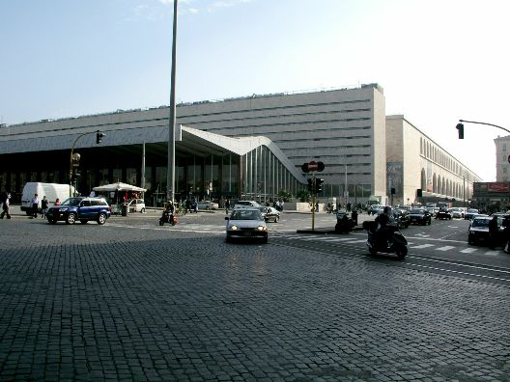

  - Coffee and welcome

- Dr Claudia Bolgia (University of Cambridge)
Ubi papa, ibi Roma: Pope, pilgrims and art in late-Trecento Rome

12.0 Professor Rosemary Sweet (University of Leicester)

The end of the Grand Tour? British visitors in Rome c. 1800-1840

- Lunch

- Elizabeth Speller (University of Cambridge)
Into battle with a Baedeker. Fighting for Rome, 1944

- Frederick Gustav Whitling (European University Institute, Florence)
Servio Tullio prende il treno. Assessing and evaluating Ancient remains at Stazione Termini

- Tea

- Special Film Screening, introduced by Professor Mary Woods (Faculty of Continuing Education, Birkbeck): shown at this year’s Tribeca Film Festival, Agostino Ferrente’s critically-acclaimed:

L’Orchestra di Piazza Vittorio

6.30 Drinks

This series is jointly organized by the Italian Department of UCL and the School of the History of Art, Film and Visual Media at Birkbeck. Admission is free but places are limited. For more information and to register, please contact the organizers: l.caldwell@ucl.ac.uk; d.caldwell@bbk.ac.uk.

