Rome
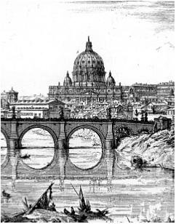
The Growth of the City from the Return
of the Popes to the Present

An Interdisciplinary Research Seminar

SEMINAR SIX:
The Papacy

16 February 2007

The British School at Rome

  - Coffee and welcome

11.00 Margaret Meserve (Notre Dame/American Academy in Rome)
News and Propaganda in Renaissance Rome: The della Rovere Popes
and the printing press

12.00 Chrysa Damianaki (Università di Lecce)
Un simbolo antipapale: la statua di Pasquino nella prima meta del
Cinquecento

1.00 Lunch

2.15 Aristotle Kallis (University of Lancaster)
Reconciling the 'second' and 'third' Rome: the opening of Via della
Conciliazione

3.15 Carlo Travaglini & Keti Lelo (Roma Tre)

Roma dall’alto

4.15 General discussion

5.00 Drinks

This series is jointly organized by the Italian Department of UCL and the School of the History of Art, Film and Visual Media at Birkbeck. For more information you can contact the organizers (l.caldwell@ucl.ac.uk; d.caldwell@bbk.ac.uk), or Susan Russell at the British School (s.russell@bsrome.it).

