Rome
The Growth of the City from the Return
of the Popes to the Present

An Interdisciplinary Research Seminar

SEMINAR FOUR:
Dealing With Ancient Rome II:
The Development of Scientific Archaeology
and the Encounter with the Modern City

2 June 2006

University College, Engineering Building, Malet Place, Room 1.20

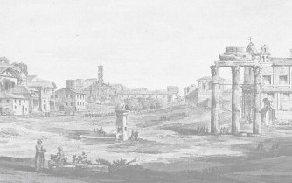
  - Coffee and welcome

- Professor John Wilton-Ely (University of Hull)

Creative Fantasy: Piranesi’s Vision of Rome

- Professor Leonardo Ciacci (Dipartimento di storia
dell’architettura, Venice University)

Rome in the thirties. A city worthy of attention

1.00 Lunch

  - Professor Andrea Vidotto (Director, Dipartimento di
Progettazione e Studi dell’architettura, Rome University, ‘Roma
Tre’)
Il sottosopra dell’archeologia Planning and design in contemporary Rome

  - Round Table discussion. Rome in 2006 past and present
Participants Amanda Claridge (Royal Holloway),
Catherine Edwards (Birkbeck College, tbc), Aristotle Kallis
(Lancaster University) Adrian Rifkin (Middlesex Univeristy)

4.15 General discussion

- Drinks

This series is jointly organized by the Italian Department of UCL and the School of the History of Art, Film and Visual Media at Birkbeck. For more information you can contact the organizers: l.caldwell@ucl.ac.uk; d.caldwell@bbk.ac.uk. Admission is free but places are limited, so if you wish to attend please contact the administrator in the UCL Italian Dept, Sue Carr (tel: 020-7679-7784; e-mail: s.carr@ucl.ac.uk).

