Rome
The Growth of the City from the Return
of the Popes to the Present

An Interdisciplinary Research Seminar

SEMINAR THREE:
Dealing With Ancient Rome I:
The Scholarship of Antiquity from the Renaissance to the Baroque

28 April 2006

Birkbeck College, 43 Gordon Square, Basement Lecture Theatre
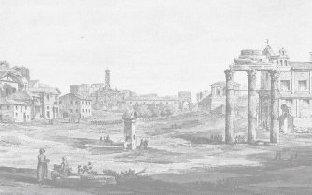
  - Coffee and welcome

11.00 Claudia LaMalfa (Università Suor Orsola Benincasa, Naples):

Before disappearing: the Oratorio di San Croce in Laterano in the Early Renaissance

12.00 David Hemsoll (University of Birmingham)

Raphael’s New Architectural Agenda

1.00 Lunch

2.15 Clare Guest (Trinity College Dublin)
Universal and Particular Significance in Pirro Ligorio's Vision of Antique Art

3.15 Ingo Herklotz (University of Marburg)

Relic Hunters vs. Scholars: The Rediscovery of Roman Catacombs in the 16th and 17th Centuries

4.15 General discussion

- Drinks

This series is jointly organized by the Italian Department of UCL and the School of the History of Art, Film and Visual Media at Birkbeck. For more information you can contact the organizers: l.caldwell@ucl.ac.uk; d.caldwell@bbk.ac.uk. Admission is free but places are limited, so if you wish to attend please contact the administrator in the UCL Italian Dept, Sue Carr (tel: 020-7679-7784; e-mail: s.carr@ucl.ac.uk).

