Rome
The Growth of the City from the Return
of the Popes to the Present

An Interdisciplinary Research Seminar
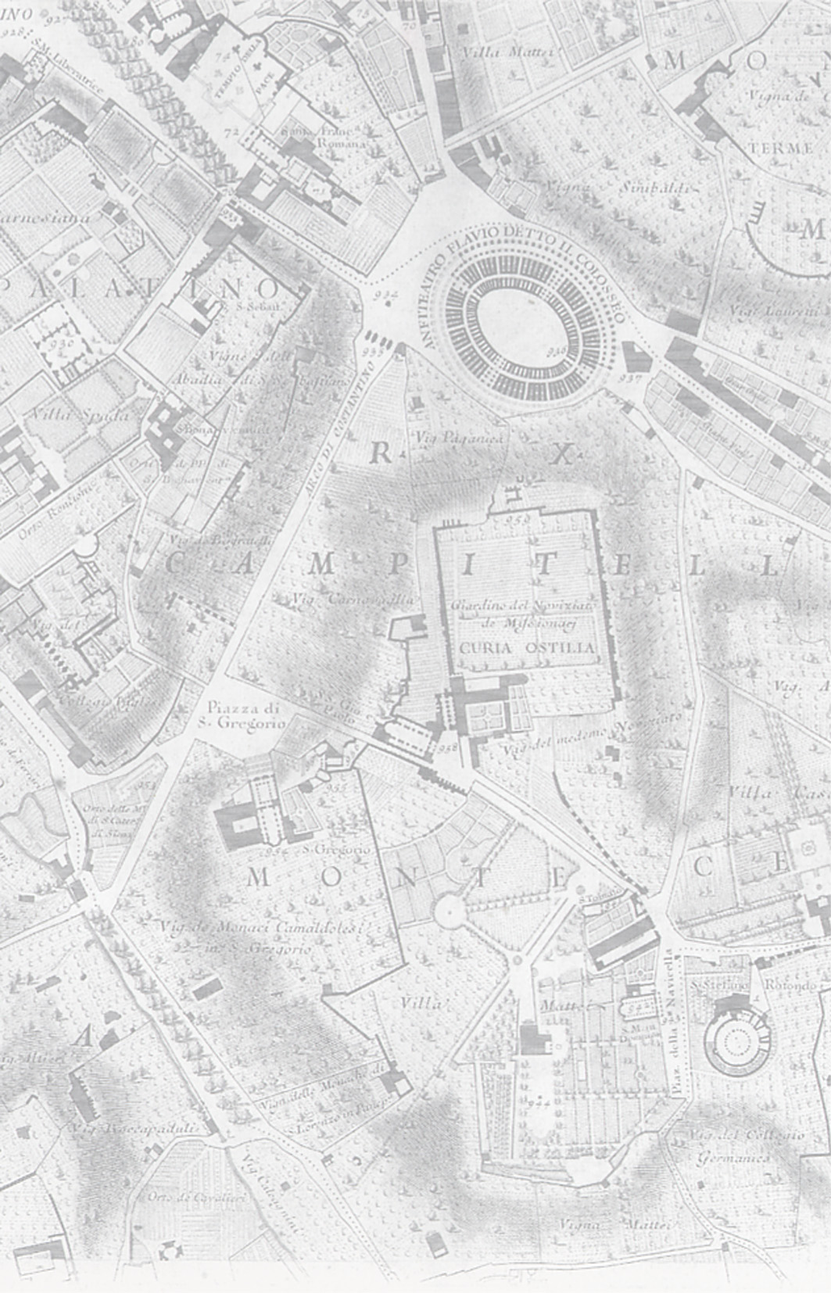

SEMINAR TWO:
Mapping the City from Bufalini to the Piani Regolatori

11 November 2005, UCL

  - Coffee and welcome

11.00 Jessica Maier (American Academy of Rome):

The Bufalini Plan of 1551 and Cinquecento Imagery of Rome

12.00 Allan Ceen (Studium Urbis, Rome)
G.B. Nolli and the turning point of Roman map making

1.00 Lunch

2.30 Terry Kirk (American University in Rome)

The Political Topography of Modern Rome, 1870-1936

3.30 Roberto Morassut (L’Assessore all’Urbanistica, Comune di Rome)

The Piano Regolatore of 2003

4.30 General discussion

5.30 Drinks

This seminar series is jointly organized by the Italian Department of UCL and the School of the History of Art, Film and Visual Media at Birkbeck. To register, s.carr@ucl.ac.uk.

the organizers: l.caldwell@ucl.ac.uk; d.caldwell@hist-art.bbk.ac.uk or the administrator in the UCL Italian Dept, Sue Carr on tel: 020-7679-7784; e-mail: s.carr@ucl.ac.uk

