ROME
The Growth of A City

L'Orchestra di Piazza Vittorio

A Documentary by Agostino Ferrente

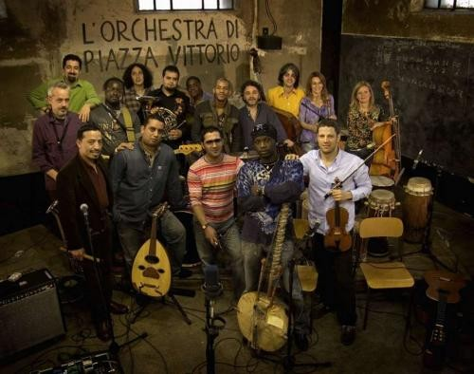

A special screening, introduced by Professor Mary Woods (Birkbeck): Critically acclaimed at this year's TRIBECA FILM FESTIVAL in New York.
FIVE years of documented material, THIRTY musicians, FIFTEEN nationalities. An extraordinary blend of individual stories, humanity and music that is not just a dream come true but
a life choice, a job and a family.

Gordon Square: Cinema
Friday 22nd June 2007
5.00pm
ROME: Growth of a City is an interdisciplinary Research Seminar
Non delegates are welcome to the screening
FREE and OPEN to all students and staff

 School of History of Art, Film & Visual Media

