Can urban interventionist groups such as the Space Hijackers challenge urban policy making?

In his keynote speech on The Heuristics of Contemporary Urban Art Interventions/Dimension, at Urban Interventions: A Symposium on Art and the City in Toronto, 2005 cultural and social scholar George Yúdice defined urban interventionism as ‘public or participatory art through which publics constitute themselves and experience something extraordinary in the process’. The artist/ curator unleashes ‘a heuristic process that is both cognitive and phenomenological’, that ‘pretends to be empowering’ and ‘seeks to recognize what strategies of change are available in the sociability or interaction that ensue from participation’ (visiblecity.ca/ video part 1).
In other words an activist art practise that challenges the built environment, its social and locational identities, policy, governance and ultimately citizenship.

In his speech Yúdice describes urban art events that are mostly funded by public institutions where the curators act as the ‘protagonists’ that invite the artist ‘for hire’ (visiblecity.ca/ video part 1) to produce interventions that catalyse interactions to suit their overall concept. These controlled, high- brow events are in keeping with the ideas of the creative city and class by ‘gurus’ such as Landry (1995, 2000) or Florida (2002), as they are putting places on the map of the global art circuit.

This brief document explores the unconventional work of the UK based activist group The Space Hijackers and more specifically their April Fools G20 Tank Action. Active since 1999, this ‘inventive and subversive group of London ‘Anarchitects’ … specialise[s] in reclaiming public spaces – usually without permission’ (TimeOut 2006). Not associated with any respected cultural body, their satirical, non-violent and unexpected interventions may be too quickly dismissed as unconstructive anarchist pranks, yet I would like to argue that they make an important socio political contribution. ‘By setting up alternative realities’ the hijackers seek to ‘re-contextualise’ (Manifesto/ spacehijackers.co.uk) public/ private space as setup by the architect planner, the council or a powerful global cooperation.

In April 2009, 11 hijackers, dressed in blue ‘boiler suits and police style helmets’ (Lewis 2010) drove their ‘riot’ tank down Bishopsgate St to position the vehicle outside the Royal Bank of Scotland to ‘protect’ the bank from the demonstrating public. The tank was painted in blue/ black and white chequered pattern, had CCTV cameras attached. After initially receiving a parking ticket all 11 agents were arrested for impersonating police, which, according to the Sunday Times, resulted in the ‘most bizarre prosecutions mounted in a British court in recent years’ (2010). Eventually the charges were dropped due to the lack of evidence, but more importantly the event fuelled public debate, surrounding the powers of London Met, especially in the context of the death of Ian Tomlinson (Lewis 2010).

In a cultural economical sense this type of anarchic creativity is difficult to be valorised, commodified or even categorised as a concrete form of art that could be curated or exhibited in a gallery, as described above by Yúdice. It is not constructive towards that ‘creative milieu’ (2000: 133), which Landry deems so important in the creative city. Neither city authorities nor urban developers could formally gain from the hijackers’ sometimes destructive, immediate and transient activities, especially as they often challenge their policy and governance. However the citizen is stimulated to rethink citizenship, the use of public spaces and powers and to challenge governance and policymaking relevant in an age of growing disengagement.
April Fools G20 Tank Action Images: 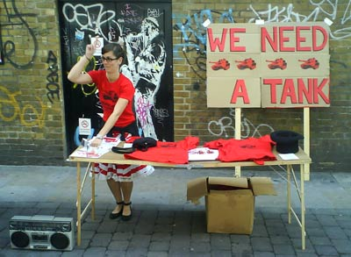
Picture 1 a (Source: Space Hijackers)



Picture 1 a + b (Source: Space Hijackers)

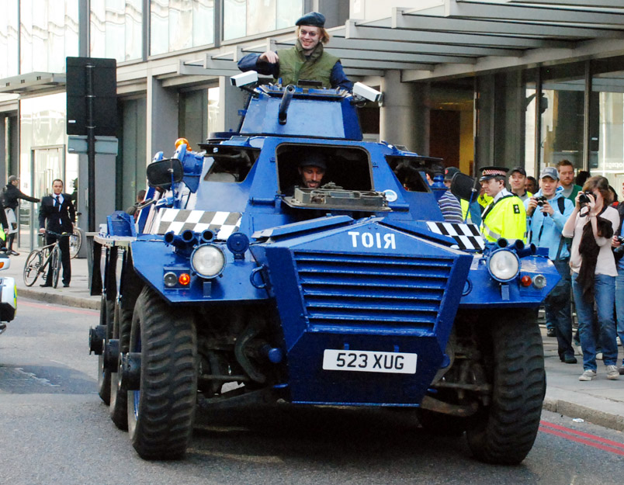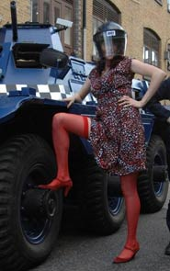

Picture 2 a + b (Source: Space Hijackers)

References and Links:

Borromeo L., (2009), Police in bras and stockings?, Guardian 01/10/2009,
http://www.guardian.co.uk/commentisfree/libertycentral/2009/oct/01/g20-protest-police-stockings-bra, accessed 27/03/10

Holmes B., (2009), Open Letter in Support of the Space Hijackers, http://brianholmes.wordpress.com/2009/10/05/open-letter-in-support-of-the-space-hijackers/, accessed 27/03/10

Florida, R. (2002), The Rise of the Creative Class, New York, Basic Books

Landry, C. (2000) The Creative City, A Toolkit for Urban Innovators, London, Comedia/Eartscan

Landry, C. and F. Bianchini (1995), The Creative City, London, Demos/ Comedia

Leppard D., (2010), Black bra, red stockings: is that a fair cop?, Sunday Times, 27/09/10, http://business.timesonline.co.uk/tol/business/law/article6850901.ece

Lewis P., (2010), Ian Tomlinson family waits for answers one year on from G20 protests, Guardian, 26/03/10, http://www.guardian.co.uk/uk/2010/mar/26/ian-tomlinson-g20-protests-anniversary, accessed 27/03/10

Space Hijackers: www.spacehijackers.co.uk

On you Tube: http://www.youtube.com/watch?v=OpmIvomCSY0, http://www.youtube.com/watch?v=_PdrzuJowBY&feature=related, http://www.youtube.com/watch?v=nwrs-IHq970&feature=related

Signs of Revolt, http://signsofrevolt.net/

Time Out (2006), London's secret scenes, 12/11/2006 12/http://www.timeout.com/london/features/1975/12.html, accessed 27/03/10

Yúdice, G. (2005), The Heuristics of Contemporary Urban Art Interventions/Dimension, keynote speech at Urban Interventions: A Symposium on Art and the City, Toronto
http://www.visiblecity.ca/index.php/lectures/86-urban-interventions, accessed 27/03/10

Ian Tomlinson’s assault on the Guardian: ttp://www.guardian.co.uk/uk/2009/apr/07/ian-tomlinson-g20-death-video

inSITE, Arte Cidade etc.
01/04/2009
Interventions have included spoof planning applications, inner city midnight cricket, the infamous circle line parties, the auction of a tank outside an weapons fair, guerrilla benching, a support stall for demonstrating police, buy nothing day and many more.
Playing Wagner's Ride of the Valkyries and partially financed though a t-shirt sale on brick lane; see picture01a/b
City of London
See picture 02 a + b
Its bumper sticker read ‘How Do You Like My Driving? 0800 F**K YOU’ (Berromeo, 2009).
Newspaper vendor Ian Tomlinson collapsed and died of a heart attack, at the G20 protests he was passing on his way home, after being assaulted by police officers. His last minuets were caught on camera by and American fund manager and the footage obtained by the Guardian days later: ttp://www.guardian.co.uk/uk/2009/apr/07/ian-tomlinson-g20-death-video

