The British stag and hen party: creativity that cities can’t control


Flickr: Steve Greaves

A mob of drunken men dressed in superhero costumes wasn’t quite what Charles Landry had in mind when he set out his vision for the creative city. But the stag and hen party, as the send-off for grooms and brides is known in Britain, challenges how creativity is defined, how it can (or can’t) be controlled, and what it can achieve.

Fancy dress is an increasingly important feature of British bachelor parties. The costumes are carefully co-ordinated to create maximum visual impact and humour, and the choice of images often serves as a filter of popular culture (as the pictures here demonstrate).

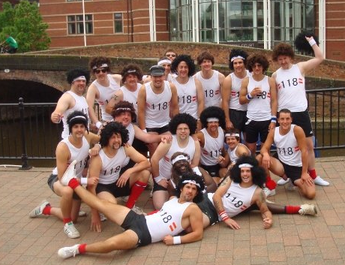

Women tend to revert to cliché, often choosing standard features such as “doodle boppers” (pictured below as headwear) or opting to create “tarty” versions of traditional costumes – tarty nuns are a popular choice.


Flickr: johanna

But nevertheless great effort goes into creating the outfits, and obvious pleasure is gained parading them through a city centre.

Creativity isn’t limited to the outfits. It is up to the bridesmaids or best man to arrange the most innovative or outlandish activities and tasks. In fact, their credentials as best friend are measured by the creativity of the party. Interestingly, reports suggest that women are now pursuing more traditional “creative” skills such as knitting and flower arranging on hen dos in order to save money (Saner, 2010).

While they seem trivial on the surface, these parties also perform an important social and cultural role. Firstly they are part of an important social institution, the marriage. The bride or groom-to-be is often singled out via costume to mark their special role. Secondly, the party has its roots in traditional festival, and draws parallels with city carnivals that revolve around fancy dress and high-octane revelry.


Flickr: Macaz21

The creative city discourse assumes creativity boosts the economy (Landry, 2000; Florida, 2002); and attracts an elite “creative class” using selective forms of artistic endeavour (Florida, 2002).

The stag party, however, does neither. Groups of rowdy men or tackily-dressed women are more likely to send Richard Florida’s creative class running (the picture below suggests why). And while these parties may generate economic growth by boosting the leisure industry, they also cost the city through policing. Bars in Barcelona have been banned from offering drinks promotions in order to curb the number of stags and hens, and the pickpockets, prostitutes and drug dealers that circle them (Govan, 2009).

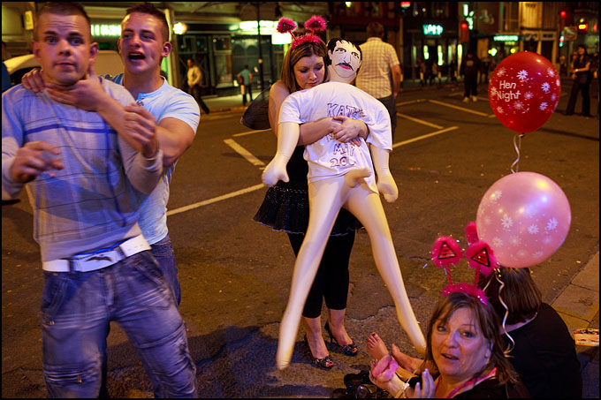
Flickr: Maciej Dakowicz

The aim of this example is not to suggest that policy making should attract stag and hen parties to city centres. Instead it redefines the creative city to gain a better understanding of what creativity can and should achieve.

Firstly, the stag party demonstrates that creativity isn’t always created by the elite and for the elite. Creativity can come from everyone, and it is valuable even if some people don’t like the outcomes.

It also demonstrates that creativity doesn’t always have positive results. Creativity is not just about making things attractive, or softening the edges of urban development. It can also challenge, oppose and unsettle the city and its occupants.

Landry says the task of the urban planner is to “recognise, manage and exploit [creative] resources responsibly” (Landry, 2000, 7). But there is a limit to how far planners can control creativity. An energetic city is also fuelled by unexpected and unruly acts.

And finally, this case study shows how creativity needn’t always generate economic benefits. Sometimes it can simply be about having some fun.

References

Landry, C. 2000. The Creative City: A Toolkit for Urban Innovators, London: Earthscan.
Florida, R.L., 2002. The Rise of the Creative Class: And How It's Transforming Work, Leisure, Community and Everyday Life, New York, NY: Basic Books.
Saner, E. 2010. Hen parties on a budget. guardian.co.uk, March 7. Available from http://www.guardian.co.uk/lifeandstyle/2010/mar/07/hen-parties-on-budget
Govan, F. 2009. Barcelona declares war on stag and hen party binge drinkers with ban on Happy Hour . Telegraph, October 12. Available from http://www.telegraph.co.uk/news/worldnews/europe/spain/6336558/Barcelona-declares-war-on-stag-and-hen-party-binge-drinkers-with-ban-on-Happy-Hour.html

