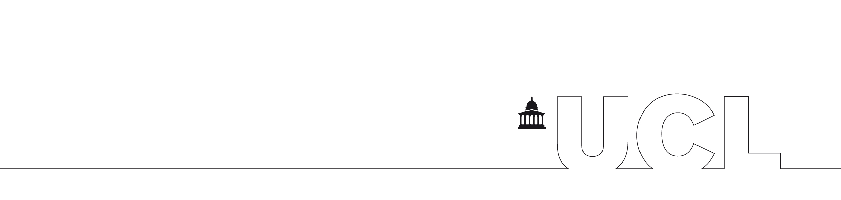

UCL BUSINESS PLC

If you have any questions in connection with the terms of the agreement, please contact Mr. Mars Bai by telephone on +44 (0)20 7679 9000, fax: +44 (0)20 7679 9838 or via email: m.bai@uclb.com.

Once this agreement has been signed on behalf of the Recipient’s Institution and the Recipient, please, post the two copies of the partially executed agreement to:

Mr. Mars Bai
Material Transfer Administrator
UCL Business plc
The Network Building
97 Tottenham Court Road
London W1T 4TP
United Kingdom

One fully executed copy will be posted to Recipient’s Institution.

UCL BUSINESS PLC

UNIVERSITY COLLEGE LONDON
Gower Street London WC1E 6BT

MATERIAL TRANSFER AGREEMENT

- UNIVERSITY COLLEGE LONDON (“UCL”) has collected and/or developed the materials known as: (Insert description of materials below)
Sox10-Cre PAC transgenic mice
and includes any constructs, strains, derivatives, obtained from or as a result of the use of the materials (the “Materials”)

- Providing University College London Scientist is: (Insert name and department)
Prof William D Richardson and Dr Nicoletta Kessaris, Wolfson Institute for Biomedical Research
(the “Provider”)

- Recipient Scientist is: (Insert name)

(the “Recipient”)

- The Recipient is an employee of: (Insert institution name and full address)

(the “Institution”)

- The Institution wishes to acquire a sample of the Materials for academic research relating to: (Insert description of academic research for which Materials are to be used)

(the “Research Programme”)

- UCL is willing to provide a sample of the Materials for a period of 5 years (the “Term”) on the Terms and Conditions shown overleaf provided the Recipient and the Institution agree to comply with those Terms and Conditions.

Standard Terms and Conditions for Release of Materials

- Institution shall keep the Materials secure at the Recipient’s laboratory and ensure that access to the Materials is restricted to the Recipient and authorised co-workers who have entered into legally binding obligations with the Institution on terms equivalent to those set out in this Agreement. In this Agreement “the Materials” shall include any and all materials, documents and information that UCL may provide to the Recipient under or in connection with this Agreement, and any derivatives, portions, progeny or improvements.

- The Institution shall use the Materials only for the Research Programme and not for any commercial purpose or commercially-sponsored research even if those purposes are being pursued in the Recipient’s laboratory without the prior written consent of UCL.

- The Institution shall not supply the Materials to any other party.

- The Term may be extended with the written agreement of UCL. Permission to extend the term of this Agreement must be sought by the Institution three (3) months before the expiry of the Term.

- The Recipient shall acknowledge UCL as the source of the materials in any publication that mentions them. The Institution shall send UCL a copy of any reports or publications which describe work carried out using the Materials, and UCL shall be entitled to use all such reports and publications.

- The Materials and any copies thereof made by or in the possession of or under the control of the Institution pursuant to this Agreement shall remain the property of UCL and shall be immediately returned or if the UCL so requires, destroyed
      - on termination of this Agreement, and
      - in the event that the Institution is in breach of any of the conditions of this Agreement, and
      - at any other time on request of UCL.
If UCL so dictates the Material should be destroyed under the circumstances that might arise under this Clause 6.

- The Materials shall at all times remain the property of UCL and will not be removed from the Institution’s address. No licence under any UCL intellectual property is granted or implied by this Agreement.

- In the event that the Recipient makes or observes any new discovery, improvement or invention (“Invention”) relating to the Materials or as a direct result of the Research Programme then the Institution will bring this to the attention of UCL. In addition, the Institution will provide to UCL at yearly intervals reports detailing the results of the Research Programme and all and any information that the Institution holds concerning the Materials. UCL will, at all times, retain the right to use an Invention for non-commercial research purposes.

- If any commercial revenues result from the Recipient’s use of the Materials, UCL shall be entitled to a fair and reasonable share of any such revenues that accrue to the Institution or the Recipient.

- The Institution shall ensure the Recipient uses the Materials in accordance with good laboratory practice and the highest standards of skill and care and shall ensure compliance with any applicable laws and regulations governing the transportation, keeping or use of the Materials.

- The Institution warrants that it has the requisite rights to use elements of the Materials that may incorporate third-party proprietary technology, including but not limited to Cre-Lox elements.

- The Materials are supplied without cost but the Institution shall reimburse UCL for any reasonable shipping and related costs that may be incurred when preparing and sending the Materials to the Recipient.

- The Materials are experimental in nature and UCL makes no representation and gives no warranty or undertaking, in relation to them. As examples, but without limiting the foregoing, UCL give no warranty:
      - that it owns all necessary property and other rights in the Materials and that their use will not infringe any patent, copyright, trade mark or other right owned by any third party; or
      - that the Materials are of merchantable or satisfactory quality or fit for any particular purpose, have been developed with reasonable care and skill or tested, for the presence of pathogens or otherwise, or are viable, safe, or non-toxic.

- UCL shall have no liability to the Institution, whether in contract, tort or otherwise, in relation to the supply of the Materials to the Recipient and/or Institution or their use or keeping by the Recipient and/or Institution or by any other person, or the consequences of their use, to the maximum extent permitted under applicable law. The Institution shall indemnify and hold harmless the Indemnified Parties from and against all Claims and Losses arising from such supply, use or keeping, including without limitation Claims and Losses arising from:
      - injury to the Institution's employees and third parties;
      - infringement of third party intellectual property rights; and
      - use of the Materials within or outside the scope of this Agreement.

- For the purposes of this Agreement:
      - “Indemnified Parties” shall mean UCL and its directors, officers, employees, representatives and associated undertakings;
      - “Claims” shall mean all demands, claims, proceedings, penalties, fines and liability (whether criminal or civil, in contract, tort or otherwise); and
      - “Losses” shall mean all losses including without limitation financial losses, damages, legal costs and other expenses of any nature whatsoever.

- The Institution agrees to be bound by this Agreement in consideration of UCL making the Materials available to the Recipient.

- English law shall apply to this Agreement, and the English courts shall have exclusive jurisdiction.

AGREED by the parties through their authorised signatories:

For and on behalf of For and on behalf of the
University College London Institution

______________________________ ______________________________
Signed Signed

______________________________ ______________________________
Print Name Print Name

______________________________ ______________________________
Title Title

______________________________ ______________________________
Date Date

Acknowledged By the Recipient

______________________________
Signed

______________________________
Print Name

______________________________
Title

______________________________
Date

