BIRKBECK COLLEGE
UNIVERSITY OF LONDON

FINANCIAL ACCOUNTING 1
2006/2007

EXERCISES

You should attempt questions from the textbooks after each lecture.

In addition, you should also prepare answers for discussion of the questions in the following tutorials.

Week 2 |  | Qs 1&2
 |  | MC1
Week 3 |  | Cliff (past midterm test) - attached
Week 4 |  | John (past midterm Test) - attached
Week 5 |  | Standish
 |  | Pine
Week 6 |  | Georgia
Week 7 |  | Mid-term test (no tutorial)
Week 8 |  | MC3  Romaro Ltd
Week 9 |  | Mount Lavinia Ltd
Week 10 |  | Viraj Ltd
Week 11 |  | Style Ltd

Week 2 –

1. State whether the following are assets, liabilities, income, expenses, capital or drawings or none of them.
- Office computers
- Owners investment in the business
- Electricity
- Amounts owed to our suppliers for purchases
- Insurance
- Letter from the bank promising an overdraft facility if needed during the next year
- Loan from the bank
- Owner takes items out of the business for his/her own personal use
- A property bought for use by the business
- A property to be rented by the business

2. State which accounting rule the accountant would most probably adopt in dealing with the following issues:
- Advertising used for in period 1 but paid for in period 2
- A proposed change in the valuation of stock
- A vehicle which could be sold for more than its purchase price
- The business has paid the income tax bill of its owner
- It is not certain whether the business will have to pay leagal fees of £1,000 or £3,000 for an upcoming court-case
- The valuation of a gallon of petrol in one vehicle at the end of the year

MC1

1. In accounting, the term ‘purchases’ means

A all items bought.
B only those goods bought and paid for.
C only those goods bought on credit.
D only those goods bought for resale.

2. If Martin’s capital at the beginning of 1997 was £150,000 and his net profit for the year was £50,000. What was his capital at the end of 1997?

A £100,000
B £150,000
C £200,000
D none of the above.

3. A sole trader’s net profit for the year may be computed using which of the following formulae?

A. opening capital + drawings - capital introduced - closing capital
B. closing capital + drawings - capital introduced - opening capital
C. closing capital - drawings + capital introduced - opening capital
D. opening capital - drawings + capital introduced -closing capital

4. The purpose of a balance sheet is to show...

A. a clear and definite estimate of what a business is really worth.
B. the amount the business could be sold for in liquidation.
C. the amount the business could be sold for as a going concern.
D. the asset of the business and the claims against those assets.

5. Which of the following are correct?

 | Assets | Liabilities | Capital
 | £ | £ | £
(i) | 5,980 | 3,450 | 2,530
(ii) | 8,200 | 2,800 | 5,400
(iii) | 9,500 | 1,390 | 10,890
(iv) | 6,540 | 1,120 | 5,420

A. (i), (ii) and (iii)
B. (i), (ii) and (iv)
C (ii), (iii) and (iv)
D. (i), (iii) and (iv)

6. The entity concept means that

A. because a firm is separated and distinct from its owners, those owners cannot have access to its assets unless the firm ceases to trade.
B. accounts must be prepare for every firm
C. the financial affairs a firm and its owner(s) are always kept separate for the purpose of preparing accounts.
D. non of the above.

7. The effect of the prudence concept is that

A. net profit is the difference between revenues and expenses rather than the difference between receipts and payments.
B. losses should be provided for as soon as they are foreseen and profit should not be recorded until they are realised.
C. similar items should be treated in a consistent way from one accounting period to the next.
D. none of the above.
Week 3 - Cliff

Cliff opened a shop on 1 July 2003 and during the first month in business, the following transactions occurred:

2003
1 July | Cliff contributed £10,000 in cash to the business out of his private bank account.
1 July | He also transferred his own car which has a second-hand value of £4,500 to the business.
2 July | He opened a business bank account by transferring £8,000 of cash in the business.
5 July | He rented premises for £1,000 per month payable in advance in cash.
6 July | He bought a second-hand machine for £580 by cheque.
6 July | He purchased some goods for resale for £1,000 from John on credit.
10 July | Susan supplied Cliff with £3,000 of goods on credit.
18 July | Cash sales for the week amounted to £2,560.
22 July | Cliff sold goods to Fred for £4,000 on credit.
31 July | Cliff settled his account with Susan by cheque
31 July | Fred sent Cliff a cheque for £2,500.
31 July | Cliff paid £150 by cheque as a part payment towards a holiday for his wife.

Requirements:

- Enter the above transactions in Cliff’s ledger accounts, balance off all the accounts and bring forward the balances as at 1 August 2003.

- Extract a trial balance as at 31 July 2003.
Week 4 – John

John opened a business to sell specialised old books on 1 October 2001. The following transactions took place during the first month of trading.

1 John put his savings of £15,000 into a business bank account on 1 October 2001.

2. He rented a shop for £2,000 per calendar month. The rental payment was made in advance on the first day of each month. A one-month deposit was also required by the landlord. John made those payments on 1 October.

3. Minor decoration was required for the shop and some bookshelves were bought. These came to £2,250 and were paid in full with cheque on 3 October.

4. John purchased old books from Antique Books Ltd. for £3,400 on credit on 5 October. It was John’s intention to mark up all books by 50% for resale purpose.

5. Book for Life Ltd. purchased half of the existing stock from John on credit on 10 October.

6 John returned £200 worth of books to Antique Books Ltd. on 15 October and paid £3,000 to settle the account on 30 October.

7. Book for Life returned £350 books at selling price to John on 24 October.

8. During the month, the following payments were made through direct debit to the business bank account:

 | £
Rates | 150
Electricity | 75
Salary to an assistant | 1,000

9. Cash sales for the month amounted to £1,345. John took £300 for personal use, leaving £250 in the cash till, before banking the rest on 31 October.

Required:

Present these transactions in T-accounts and extract the closing balances to the trial balance as at 31 October.
Week 5
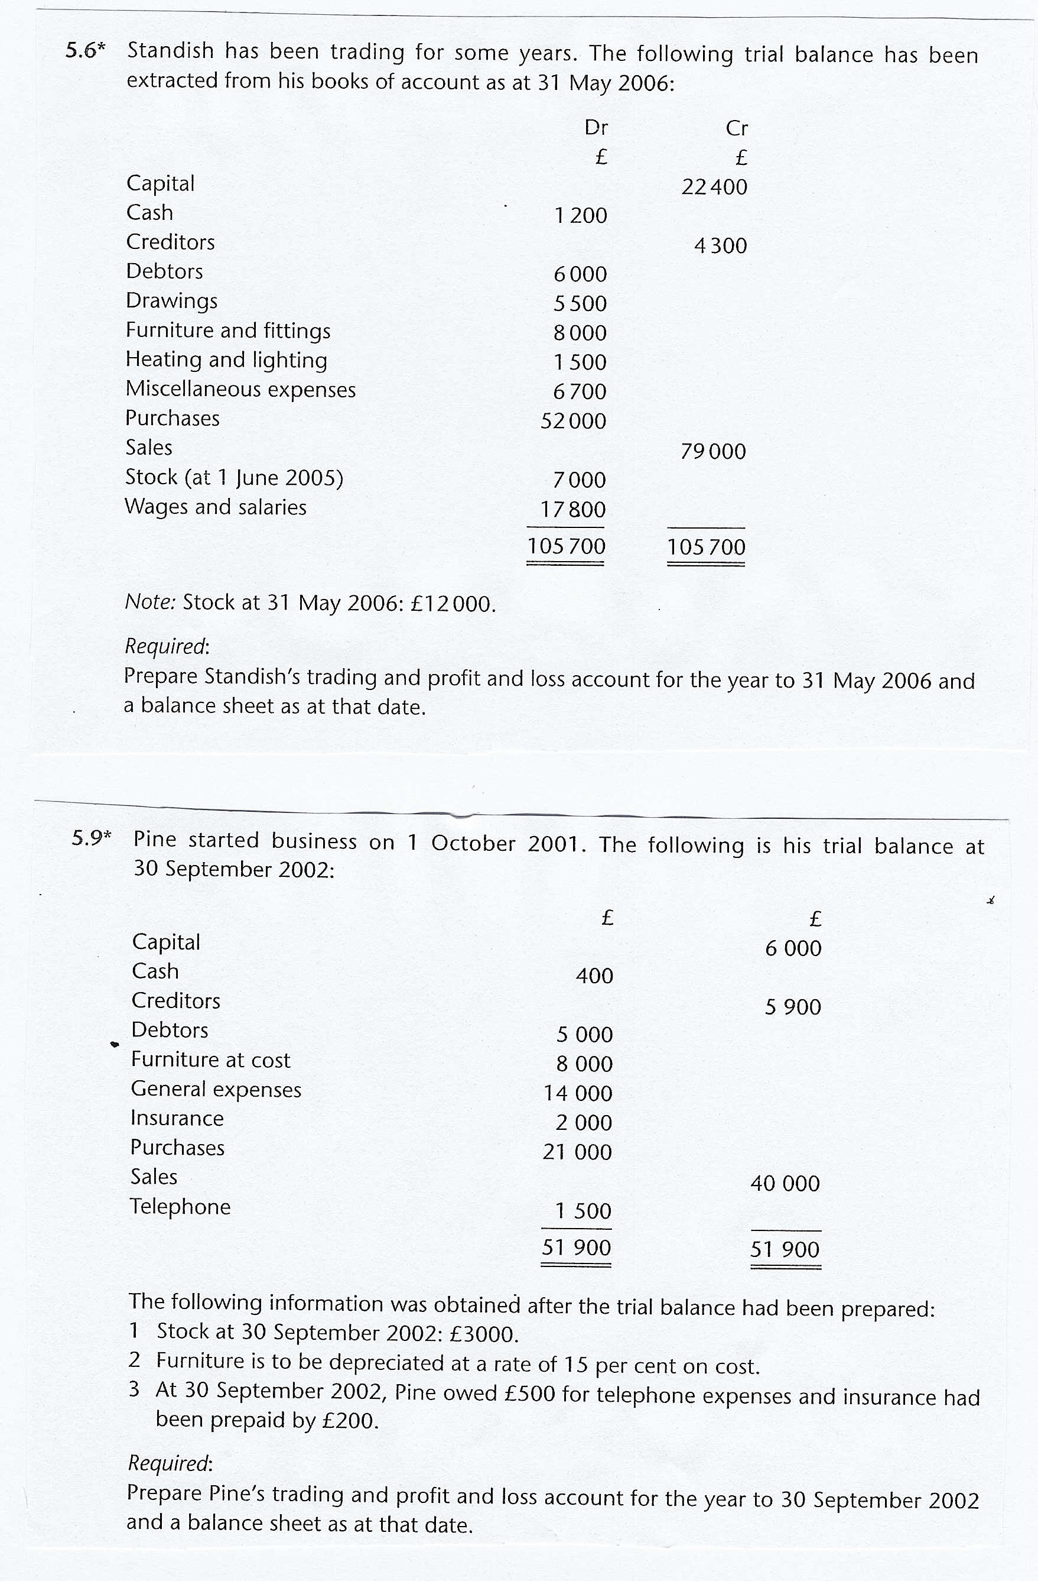

MC2

1. If a £1,000 salaries accrual was, by mistake, treated as a prepayment, the net profit would be

A overstated by £1,000.
B understated by £1,000.
C overstated by £2,000.
D understated by £2,000.

- If an item of stock which originally cost £2,840 can be sold for £3,200, after incurring further completion costs of £220 and advertising costs of £260, then it should be included in the balance sheet stock valuation at

A £2,720
B £2,840
C £2,980
D £3,200

- If the sales of a retail store during a year amount to £60,000 and the store has a mark-up of 20%, the gross profit is

A £10,000
B £12,000
C £15,000
D £20,000

- At 31 December 1996, ABC Ltd. had a £3,000 provision for doubtful debts. During the year ended 31 December 1997, bad debts of £1,450 had been written off. The trade debtor balance at 31 December 1997 was £76,500. The company wished to carry forward a general provision for doubtful debts of 3%. The charge for bad and doubtful debts in the profit and loss account for the year ended 31 December 1997 is

A £705
B £745
C £1,400
D £2,155

Week 6

The following information relates to Georgia’s ledger accounts:

 | Purchases |  | Sales
Date | Quantity | Price per unit | Quantity
2000 | (units) | £ | (units)
January | 100 | 50
February | 150 | 52 | 200
March | 200 | 55
April | 250 | 56 | 300
May | 150 | 53
June | 100 | 51 | 400

Stock at 1 January 2000: 50 units at £52 each. Selling price was £75 per unit throughout the first six months of 2000.

Required:

(a) Calculate the cost of the closing stock at 30 June 2000 and prepare a profit and loss statement for the first six months of 2000, using each of the following assumptions:

(i) FIFO (first-in-first-out);
(ii) LIFO (last-in-first-out);
(iii) Average cost (over six months)

(b) Explain carefully the considerations for choosing the appropriate stock valuation method in the situation described above.

Week 8
MC3

1. At 1 June 1997 a business had a car at net book value of £1,050, debtors of £2,500, cash of £750 and creditors of £1,375.

During the year ended 31 May 1998 the proprietor had taken goods costing £100 for his own use and had introduced further capital of £1,250 to assist in the purchase of a further car costing £4,000.

At 31 May 1998, in addition to the cars, the business also had debtors of £3,750 and creditors of £1,000. The cash book showed a balance of £500 which was before accounting for drawings of £300.

What was the profit before depreciation for the year ended 31 May 1998?

A £3,760
B £4,125
C £4,325
D £4,875

- After preparing its profit and loss account for a calendar year, in which it reported a net profit of £20,000, a firm discovered that its stock at 1 January had been under-stated by £2,000 and that its stock at 31 December had been over-valued by £3,000. The firm’s reported net profit for the year should have been

A £15,000
B £19,000
C £21,000
D £25,000

3. DNA Ltd’s stock valuation includes certain damaged goods at their original cost of £3,000. They could be repaired at a cost of £680 and sold for £3,560. The effect on DNA Ltd’s profit of including these goods at cost is that:

A profit is overstated by £680.
B profit is overstated by £560.
C profit is overstated by £120.
D profit is unchanged.

4. If the total sales of a firm for the month ended 31 March 1998 was £30,000 and its gross profit was equal to 20% of its total sales, its cost of sales was

A £20,000
B £22,500
C £24,000
D £25,000

- A company bought a machine for £46,000. The machine is expected to have a useful economic life of 8 years and a residual value of £6,000 at the end of its life. The company uses the straight line method for depreciation of this kind of asset. The annual depreciation charge, in respect of this machine, will be

A £5,000
B £5,750
C £6,000

D £6,500

- A business bought a machine for £40,000 on 1 January 1995 and depreciates it at 20% per annum by employing the reducing balance method. What is the depreciation charge for the third year of the machine’s use?

A £8,000
B £6,400
C £5,120
D £4,096

- The machine in Question 6 above was disposed of for £20,000 on 1 January 1998. Which of the following statements is correct?

A A profit of £480 is credited to the profit and loss account.
B A loss of £480 is debited to the profit and loss account.
C A profit of £5,600 is credited to the profit and loss account.
D A loss of £5,600 is credited to the profit and loss account.

The balance sheet of Romaro Ltd as at 30 April 2005 showed the following information regarding motor vehicles:

 | £ | £
Fixed Assets
Motor Vehicles at cost | 23,000
Less: Accumulated depreciation | 14,000 | 9,000

It is company policy to depreciate motor vehicles at the rate of 15% on the cost of assets held at the end of each year.

The company purchased, on 1 January 2006 a motor van for £4,000. A motor van purchased on 1 January 2004 for £3,000 was traded in for the new vehicle and £1,800 cash was paid in full settlement.

In addition, a motor car purchased on 1 January 2003 for £3,500 was involved in an accident during March 2006 and has been declared a write-off. The company’s insurers have agreed to pay £1,800 as compensation for the loss.

Required

- The motor vehicles disposals account for the year ended 30 April 2006

- The accumulated depreciation (provision for depreciation) account for motor vehicles for the year ended 30 April 2006

- The appropriate figures relating to motor vehicles in the balance sheet at 30 April 2006

Week 9

The following trial balance has been extracted from Mount Lavinia Ltd.
The trial balance of Mount Lavinia Ltd as at 31st October 2000
 | £ | £
Bank | 340,259
Creditors |  | 58,799
Debentures 8% |  | 91,000
Debtors | 494,666
Selling expenses | 89,040
Administration expenses | 237,440
Bank interest received |  | 19,600
Motor Vehicles | 560,000
Motor Vehicles - Accumulated depreciation |  | 78,400
Ordinary share capital (50p) |  | 280,000
Ordinary dividend paid | 16,800
Preference share capital (6%) |  | 42,000
Profit and loss b/f |  | 112,588
Purchases | 1,751,120
Rent | 16,800
Sales |  | 2,968,000
Stock (opening) | 87,556
Audit fees | 11,200
Director's Remuneration | 78,400
Provision for doubtful debts |  | 36,324
Cash | 3,430
 | 3,686,711 | 3,686,711

Additional information:
- Closing stock is £218,890.
- Motor vehicles are to be depreciated by 5% each year under the reducing balance basis.
- Doubtful debts are to be 9% of the year end debtors. (round to the nearest £)
- Of the selling expenses, £11,000 related to payments made in advance for next year. Rent of £7,200 is still unpaid from this year.
- The debenture interest expense for the year has still to be paid.
- The company has issued 50p Ordinary shares. In addition to the interim ordinary dividend already paid, a final ordinary dividend of 8p per share has been proposed. The preference dividend has to still be paid.
- A general reserve of £157,356 is to be set up out of this year’s profits.
- Tax for the year is to be £269,753.

a) Prepare Mount Lavinia Ltd’s trading and profit & loss & appropriation account for the year end 31 October 2000 and a balance sheet as at that date.
Week 10
The following information relates to Viraj Ltd for the year ended 30.11.01
The trial balance of Viraj Ltd as at 30th November 2001
 | £ | £
Profit and loss b/f |  | 41,723
General Reserve |  | 47,850
Ordinary dividend | 5,280
Preference dividend | 2,640
Ordinary share capital (£0.50) |  | 300,000
Preference share capital (9%) |  | 99,000
Bank | 172,174
Cash | 25,773
Debtors | 318,440
Provision for doubtful debts |  | 8,145
Trade Creditors |  | 46,200
Audit fees | 20,698
Electricity | 28,910
Rent & Rates | 30,525
Discounts allowed | 31,845
Insurance | 9,329
Directors remuneration | 107,910
Wages & Salaries | 75,331
Motor Vehicles | 420,090
Motor Vehicles - Accumulated depreciation |  | 47,190
Fixtures & Fittings | 129,520
Fixtures & Fittings - Accumulated depreciation |  | 28,710
Debentures 7% |  | 363,000
Purchases | 1,090,691
Sales |  | 1,592,250
Stock (opening) | 152,696
Discounts received |  | 47,784
 | 2,621,867 | 2,621,867
You are also given the following information:
- Closing stock =£189,343
- Motor Vehicles are to be depreciated by 12% under the reducing balance method. Fixtures & Fittings is to be depreciated by 10% of cost.
- Bad debts for the year are £15,640. Doubtful debts are to be 3% of the remaining debtors.
- The debenture interest is still to be paid.
- There are sufficient profits to pay the preference dividend.
- A final ordinary dividend of 8p per share is proposed.
- The company has just received an invoice for training expenses of £17,000 and an invoice of £9,000 for electricity relating to the year just ended. £2,700 of the insurance paid and £8,600 of the rent & rates relates to next year.
- The corporation tax charge is £51,259.
- The board of directors would like to set aside £28,000 to the General Reserve.
a) Using the information above, prepare the
- profit & loss & appropriation account for the year ended 30th November 2001
- balance sheet as at that date
Week 11
