Student no.: 1021444 28 March 2011

Creative Cities Assignment

La Sape: Turning Creative City Narratives Inside Out

La Sape (La Société des Ambianceurs et des Personnes Élégantes) is a Congolese movement, commonly referred to as a ‘cult of appearance,’ whose exclusively male members seek to dress conspicuously in Parisian haute couture as part of complex political and cultural manoeuvre(s). Many travel to and work in Paris as working-class migrants in order to realise their ambition in Brazzaville. Some members go as far as to wear items inside-out in order to brandish fashion labels. Drawing upon this practice as metaphor, La Sape provides an opportunity to critique and extend creative city logic while overtly exposing its tensions.

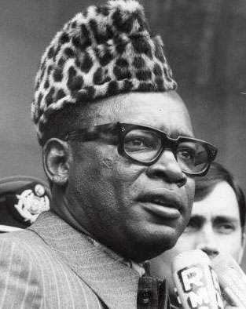
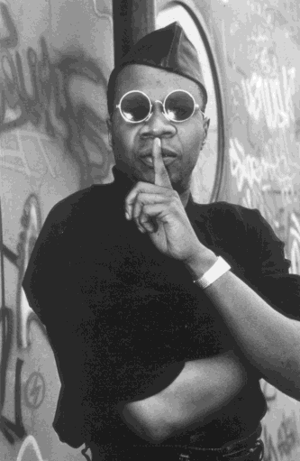
Creative city practitioners uphold the idea that cities, should they wish to maintain the competitive edge, should collectively constitute a series of reproduced spaces insofar as they should attract the creative class who have fundamental ‘infrastructural’ requirements (Florida 2002). The creative class is in turn figured as a stable group of mobile, apolitical and contemporised people who occupy a fluid urban terrain. The case of La Sape destabilises this notion however; it speaks to the need to attend more consciously to the politics and history of interstitial flows between cities as part of a relational comparative approach (Ward 2010) and, more particularly, to address ways in which the post-colonial might frame creative ‘mobility.’ La Sape was born out of a wave of popular resistance to Mobutu’s (Plate 1) regime of authenticity, which prescribed a denunciation of symbolic ties with the coloniser and a ‘return’ to traditionalism. Papa Wemba (Plate 2), the celebrated face of Congolese music, is accredited with founding La Sape as part of a popular reclamation of cultural agency. It is out of this political complexity which a post-colonial creative ambiguity arose.

Plate 1 Mobutu Sese Seko Plate 2 Papa Wemba (Source: Mode Parade 2010) (Source: Collins 2002)
The spatial, social and economic duality inherent in the way sapeurs mobilise social and material capital is instructive. Sapeurs occupy both Paris and Brazzaville and are at once working class migrants and cultural heroes. This suggests the need to encompass migrancy in urban creativity narratives, lending to the debate the idea that one cannot attend to a particular city’s creative configurations without attending to the ‘hinterlands’ to which they are connected and from which they derive benefit. Creative practice might arise from engagements with multiple spaces and identities at once, suggesting the need for a conception of the synchronicity of space (following Massey 1993). This further makes a case for foregrounding personal and collective aspiration and discipline as crucial to the creative process, in the face of the creative class narrative’s delineation of an a priori and generic membership. Gondola (1999:23) describes the process which sapeurs undergo as one of moving “from social dereliction to psychological redemption.” This is an incomplete observation, however, for it is the social dereliction which sustains sapeurs’ ‘redemption’ on return, an ambiguity which photographers have been quick to aestheticise (Plates 3 and 4). Sapeur practice therefore equally exposes the kinds of systemic inequalities (including those of a gendered nature as per La Sape’s exclusive male organisation) upon which notions (and realities) of the creative class rely.
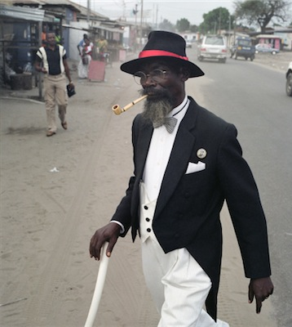
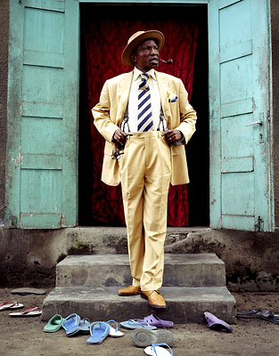
Plate 3 A Sapeur Plate 4 A Sapeur (Source: Hector Mediavilla 2007) (Source: Francesco Giusti 2010)
La Sape, as a critical device, offers to re-mix the theoretical palette board from which the ‘creative class’ is figured. It speaks to the need for a comparative urban approach and necessitates the inclusion of new registers and closer readings of the political, historical and personal in creative city imaginaries.

References
Collins, J. (2002) ‘African Popular Music: a historical review of sub-Saharan Africa’, [Online], Available: http://aatpm.com/AfricanPopularMusicCollins.htm [20/02/11].
Florida, R. (2002) The Rise of the Creative Class: And How It’s Transforming Work, Leisure, Community and Everyday Life. New York: Basic Books.
Giusti, F. (2010) ‘SAPE Viewbook Photostory’, [Online], Available: http://www.viewbookphotostory.com/2009/10/sape/ [20/02/11].
Gondola, C.D. (1999) ‘Dream and Drama: The Search for Elegance among Congolese Youth’, African Studies Review, 42 (1): 23-48.
Massey, D. (1993) 'Politics and space/time', In Keith, M. and Pile, S. (eds), Place and the Politics of Identity, London: Routledge.
Mediavilla, H. (2007) ‘The Congolese Sape’, [Online], Available: http://zonezero.com/exposiciones/fotografos/mediavilla/index.html [20/02/11].
Mode Parade (2010) ‘Dictates’ [Online], Available: http://barimavox.blogspot.com/2010/05/dictates.html [22/02/11].
Thomas, D. (2003) ‘Fashion Matters: "La Sape" and Vestimentary Codes in Transnational Contexts and Urban Diasporas’, MLN, 118 (4), French Issue: 947-973.
Ward, K. (2010) ‘Towards a relational comparative approach to the study of cities’, Progress in Human Geography 34(4): 471–487.

