100329_Urban Regeneration_Reclaiming lost territory

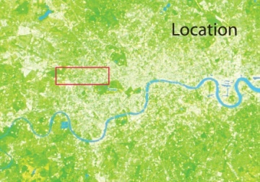 One’s improvement can be the other one’s decline. The construction of the London Westway was seen as a solution for the city’s chronic traffic problems. The two mile long motorway promised to bring the growing traffic in and out of town more efficiently, but divided neighbourhoods and communities along its route.

Providing an elevated view of the city and hiding the world underneath, the Westway lifts drivers above the roofscape of suburbia and carries them past residential tower blocks and office buildings before it drops down and delivers them in Central London.
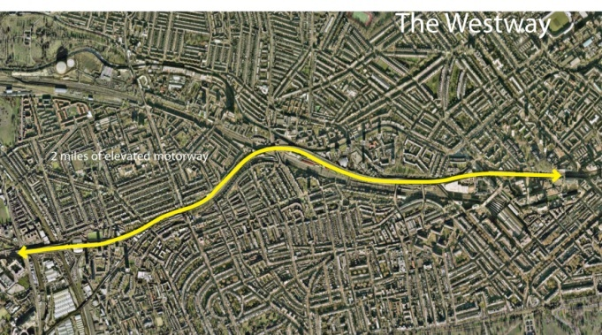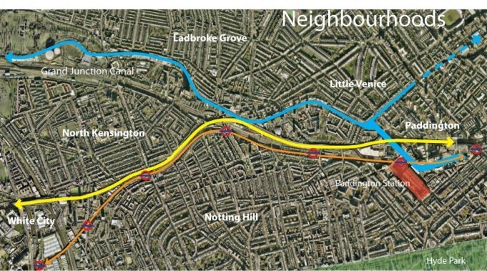

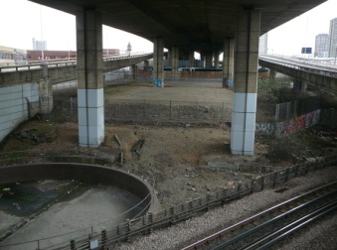JG Ballard’s book Concrete Island (2008) explores the relationship between these two worlds. In the early 1970s, Robert Maitland, the young protagonist, speeds in his sports car along the newly built Westway, loses control of his vehicle, breaks through a crash barrier and plunges down an embankment. Injured and unable to escape the deserted world underneath the elevated motorway, Maitland finds himself imprisoned on an isolated traffic island. The book describes both worlds – above and below – unable and unwilling to connect and to take notice of each other.

Since the days of Robert Maitland, the wounds cut into the built and social fabric of the surrounding neighbourhoods have slowly healed. Deserted wasteland has been reclaimed and reoccupied. Small-scale interventions, such as sport and leisure facilities, community halls, work spaces for artists and small businesses, restaurants, bars and clubs added to the social infrastructure of North Kensington and established vibrant community centres along its route.

The regeneration that has been taking place stands in stark contrast to the regeneration of other London neighbourhoods such as Islington and Hoxton, which reassemble the blueprint of Richard Florida’s writing about human capital and urban-regional growth (Florida, 2005). Far from being gentrified, the redevelopment of North Kensington can nevertheless be described as a success-story and be a potential alternative to Florida’s theory about urban regeneration.

Both models offer vibrant and lively neighbourhoods but cater for different social stratums. North Kensington was and still is a predominantly working-class neighbourhood and has not been dominated by an influx of Florida’s “Creative Class” (2005). Urban regeneration has therefore not been the consequence of new resident groups moving into the area and demanding upmarket and exclusive facilities.
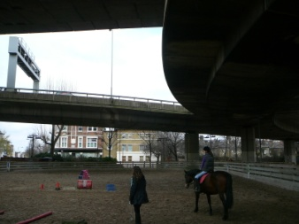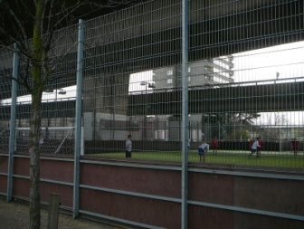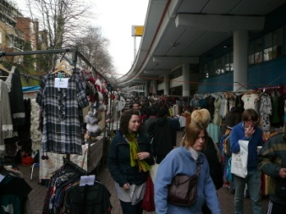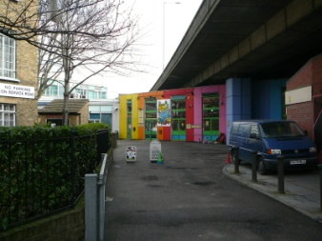
The regeneration of the neighbourhood has been initiated by local working-class residents – a group, underestimated by Florida. After failing to stop the motorway from being built, they founded the Westway Development Trust, a charitable organisation, which aims to “develop the challenging environment under the motorway in a sustainable fashion with regeneration that benefits the local community by its use and amenity value” (Westway Development Trust). Rather than regeneration through gentrification, as promoted by Richard Florida, they successfully worked toward an inclusive strategy that caters for the needs of all different social groups and therefore avoided displacement.

The case study of North Kensington offers an alternative view on Richard Florida’s work. It raises the question in how far success of urban regeneration should solely be measured against economic growth. Florida and many policy makers praise the gentrification of neighbourhoods such as Islington and Hoxton and accept displacement as an unavoidable consequence. The work of the Westway Development Trust in North Kensington though shows that the key for successful regeneration is the creation of vibrant communities, accessible to all residents.

Should Robert Maitland crash with his car today, 40 years after the opening of the Westway, he would find himself in a rather different environment.

Works Cited
Ballard, J. (2008). Concrete Island. London: Harper Perennial.
Florida, R. (2005). Cities and the Creative Class. New York; London: Routledge.
Westway Development Trust. (n.d.). About us: Westway Development Trust. Retrieved March 27, 2010, from Westway Development Trust: http://www.westway.org/westway/westway.aspx

