 | 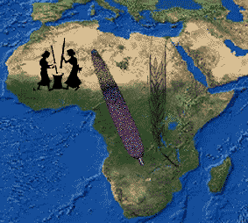 |   2nd-5th July, 2006
Institute of Archaeology, University College London
31-34 Gordon Square, London, England, WC1H OPY
Web site: http://www.homepages.ucl.ac.uk/~tcrndfu/IWAA/index.htm
Fax - (+44) (0) 207-383-2572

Pre-registration form

We are pleased to announce the 5th International Workshop for African Archaeobotany. If you would like to attend, please provide the following information. You may fill the form out on our web page, scan the form and e-mail it us as a .pdf or .rtf file, fax it or send it to us by post to the above address.

Participant (please mark where applicable)
Full (£65) ……… Student (£35) ………

Title Prof. ……… Dr. ………. Mr. ……… Ms. ……… Other (specify) ………
Name
……………………………… ……………… ……………………………
Family name Middle initial Given name
Mailing address
…………………………………………………………………………………
Street and Number

…………………………………………………………………………………
City (& State) Country Post code

…………………………………………………………………………………
Telephone Fax

…………………………………………………………………………………
E-mail
Preferred mode of contact: E-mail …… Regular mail …… Fax ……
I plan to present: Paper ………. Poster ………. Both ……….
My provisional title will be: …………………………………………………
…………………………………………………………………………………
…………………………………………………………………………………

We look forward to your participation! Thank you

Dorian Fuller & Mary Anne Murray
Co-organisers

